Getting Ready to Graduate

*Created: Aug. 2017*

*Updated: Aug. 2017*

**What to do after your generals…**

General information about CEE Ph.D. – <https://www.ce.washington.edu/current/phd>

**Set up your reading committee**

It’s at least 3 people, 1 who is your advisor, from your supervisory committee. Members can include those who may not be faculty, such as a consultant or agency staff. Talk with your advisor about who you would like and then provide the names to CEE Graduate Program Advisor (Melissa Pritchard - [chaelan@uw.edu](mailto:chaelan@uw.edu)) the **quarter before** you plan to defend.

**Getting ready to defend**

* Obtain agreement from your advisor that you are ready and want to defend.
* You must be enrolled the quarter you defend!
* Survey your committee members for possible times to schedule your defense data/time, such as <http://whenisgood.net/>.
* The only member that has to be present is your graduate school representative (GSR), others including your advisor can remote in; however, ensure that you won’t lose connection. For more about video conferencing: <https://www.ce.washington.edu/current/phd/milestones/video>
* When date/time confirmed, schedule a doctoral final exam via [MyGrad – Student View](http://grad.uw.edu/for-students-and-post-docs/mygrad-program/).
* Locate a room to defend. Make sure it has the chairs and audio-visual setup you need. For room EEB 303: use room event request that you can make yourself at: <https://www2.ee.washington.edu/operations/calendars/index.html>
* Provide a copy of your dissertation to your full committee **2 week prior** to defending.
* Provide CEE Graduate Program Advisor an abstract announcement of your dissertation **1 to 2 weeks before** your defense, including the date/time/room, Chair of your committee (advisor), dissertation title, and abstract.
* Give your advisor or whoever is introducing you a brief bio of you prior to defense date.
* Check with your advisor about the “Warrant for Final Examination for the Doctoral Degree” paperwork for your defense, will they obtain it from the Graduate Program Advisor or shall you pick it up to bring to the defense?
* Test run your presentation in the room you have reserved and with a small audience if possible.
* Complete the following CEE online forms by the end of your final quarter (these are different than the SED survey later on):
  + [Final Check-out Form](https://catalyst.uw.edu/webq/survey/llatal/133126)
  + [Exit Survey](https://catalyst.uw.edu/webq/survey/llatal/302992)

**Defending your dissertation**

Some advice for your special day!

* Get someone else to handle the snacks…you’ve got enough on your “plate”.
* Think about what you want to do afterwards and have it pre-planned.
* Check that the “Warrant for Final Examination for the Doctoral Degree” is in the room (either brought by your advisor or you).
* Eat something beforehand, but not too much and have some water (not cold) during your presentation.
* Bring a copy of your dissertation for use during the discussion after your presentation.
* Stand to the left of your presentation…so audience ‘reads’ the presentation from left (you) to right (slide) like a book.
* Try not to read your slides and have a pointer to guide audience through your slides.
* Have joke ready in case you have technical difficulties.
* Have someone take notes on the questions that come up at end, so you can follow-up if necessary (you’ll forget them).
* Put extra slides of figures you might want to use during Q&A session at the end.
* Make sure your signed warrant goes back to Graduate Program Advisor.

**Preparing your final dissertation document**

General webpage with required sections - <http://grad.uw.edu/for-students-and-post-docs/thesisdissertation/final-submission-of-your-thesisdissertation/required-sections-for-your-document/>

* Decide what you want the title of your dissertation to be, get buyoff from advisor.
* The link above has examples of the required ‘Front matter’ format for your dissertation including: Title page, copyright page, and abstract (double spaced).
* Your ‘Name of degree’ is “Doctor of Philosophy” and program authorized to offer degree is “Department of Civil and Environmental Engineering”.
* Think about your acknowledgements, including funding agencies.
* Attach published papers (with co-authors) or close-to-submitting papers (without co-authors) as chapters. These can be with figures at end of chapters or within text and each chapter can have its own references.
* Set up a table of contents (use heading styles in Word), list of figures, and list of tables. Use ‘bookmarks’ and ‘Cross-references’ for the lists page numbering in Word.
* Format figure and table numbers sequentially, which may not match original numbers in papers. Try using a chapter prefix and then the figure number, such as Fig. 3.1.
* Save final version as PDF for upload, but check the PDF to see if the conversion worked (e.g., look at equations and figures).
* Obtain reading committee signatures on the [Doctoral Dissertation Reading Committee Approval Form](http://grad.uw.edu/wordpress/wp-content/uploads/phd-approval-form.pdf) and scan as a PDF. You can keep the original or give it to Graduate Program Advisor, but they don’t really need it.
* Published papers you want to include in your dissertation will need a license agreement from the publisher that grants you permission to include the paper. To request this agreement, go to the journal website or author dashboard of the journal you published in. There is typically a way to request use of your paper in a dissertation via a standard box to check.  You should receive an email with an attached license like the example below. In the case of UW, all theses and dissertation are required by the University to be made available on an open access basis, so confirm with the paper publisher that the agreement includes this understanding. 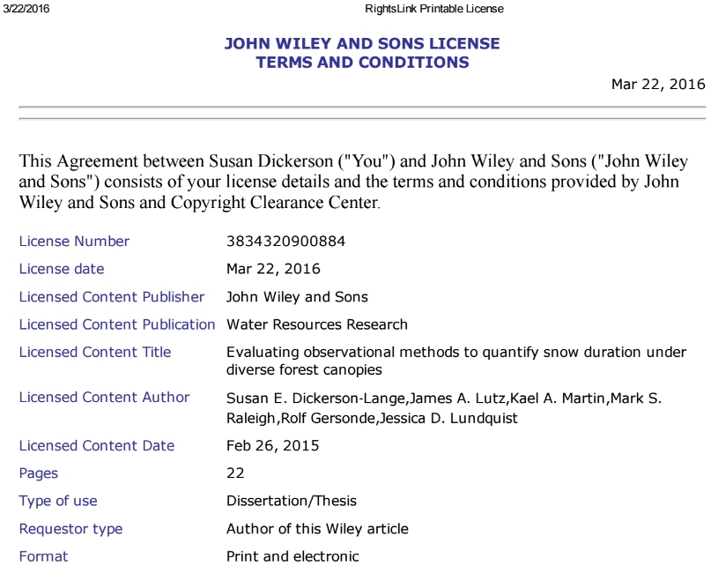

**Submitting your dissertation**

General webpage –

<http://grad.uw.edu/for-students-and-post-docs/thesisdissertation/final-submission-of-your-thesisdissertation/>

Set up an account with [UW ETD Administrator Site](http://www.etdadmin.com/washington). ETD stands for Electronic Thesis/Dissertation, where you’ll be uploading your dissertation and all other necessary approval forms. You can go in and out of this as you obtain the necessary material, so your entries are saved.

Copyrighting and publishing:

This is a bit tricky, so start with reviewing this page on “[Electronic Thesis and Disseratations – Copyright, Open Access and Publishing FAQ](http://digital.lib.washington.edu/etd-faq.html)”. The UW supports embargos of dissertations for up to 5 years. When you are filling out the paperwork at the time you submit your dissertation, you will be asked if you would like to embargo your dissertation and for how long. When a dissertation is embargoed, it is still available to the UW community, but the not wider community. Below is a screen shot of this section from the ETD submittal site.

Select Publishing Options 
Access options (e.g., delaying the release of your work) 
If you choose to delay the release of your work, access to the full text of your work will be delayed for 
work will be available through ProQuest and may be available through your institutional repository. 
Note: Most institutions have delayed release (or embargo) policies. Please consult with your Graduate 
Delaying release in ProQuest 
I want my work to be available in ProQuest as soon as it is published. 
O 
Yes 
O No - I have patents pending, or another reason why I need to delay access to the full text of my wc 
How long would you like to delay the release to ProQuest? * (more info) 
O 
o I yea O 
6 months 
2 years 
Note to administrator (optional): 
University of Washington supports embargo policies. 
Reason for delaying release to ProQuest: 
200 characters 
Clear 
Other 
Please explain: 
University of Washington supports embargo policies. 

Complete the [Survey of Earned Doctorates (SED)](https://sed.norc.org/survey) NSF online survey and obtain certificate of completion email. This takes about 25 minutes, so don’t wait until the “11th” hour.

Things you’ll have to submit to ETD Administrator:

* PDF of your dissertation and any supplemental material (e.g., spreadsheets)
* PDF of your signed [Doctoral Dissertation Reading Committee Approval Form](http://grad.uw.edu/wordpress/wp-content/uploads/phd-approval-form.pdf)
* PDFs of copyright license agreements to allow published papers in your dissertation.
* PDF of your SED Certificate of Completion

After you complete the ETA sections, you will see the message below.

Submission in Review 
Thank you for your payment! We will send you a receipt. You have successfully submitted your dissertation or thesis to your 
institutional administrator for review. 
You will receive follow-up emails concerning any necessary revisions to your submission, and to let you know when your work is ready to deliver to 
ProQuest. 
Access your work or check the status of your submission. Other questions about your submission? Contact your graduate office. 
Your order information 
Payment summary 
Print 
Submission ID: 
Payment date: 
Confirmation number: 
washingtonl 7730 
2017-08-18 14:33 (UTC-7:OO) 
60641827956 

Once you’ve submitted everything and hit the ‘submit’ button, you will receive an email from ETD Administrator that your dissertation has been submitted. This means that you’re done and the University of Washington is reviewing it. You likely won’t hear back from ‘The Graduate School’ until 2 weeks after the quarter ends that all degree requirements have been reviewed and hopefully no hiccups were found.

NOW GO CELEBRATE!